LAB 7 REPORT

NAME: FONG WEI TZE

STUDENT ID: 22030274

**PART A: Packet Tracer - Configure Initial Switch Settings**

**Part 1: Verify the Default Switch Configuration**

**Enter privileged EXEC mode.**

**Examine the current switch configuration.**

**How many Fast Ethernet interfaces does the switch have?**

24

**How many Gigabit Ethernet interfaces does the switch have?**

2

**What is the range of values shown for the vty lines?**

0 to 15

**Which command will display the current contents of non-volatile random-access memory (NVRAM)?**

show startup-config

**Why does the switch respond with “startup-config is not present?”**

The configuration file is not saved to the NVRAM.

**Part 2: Create a Basic Switch Configuration**

**Assign a name to a switch.**

**Secure access to the console line.**

**Why is the login command required?**

To tell Cisco IOS to prompt for the password.

**Verify that console access is secured.**

**Secure privileged mode access.**

**Verify that privileged mode access is secure.**

**Configure an encrypted password to secure access to privileged mode.**

**Verify that the enable secret password is added to the configuration file.**

**What is displayed for the enable secret password?**

$1$mERr$ILwq/b7kc.7X/ejA4Aosn0

**Why is the enable secret password displayed differently from what we configured?**

To make the password more secure.

**Encrypt the enable and console passwords.**

**Part 3: Configure a MOTD Banner**

**Configure a MOTD Banner**

**When will this banner be displayed?**

When accessing the switch console.

**Why should every switch have a MOTD banner?**

**The MOTD banner is used to warn unauthorized users that access to the switch console is unauthorized.**

**Part 4: Save and Verify Configuration Files to NVRAM**

**What is the shortest, abbreviated version of the copy running-config startup-config command?**

copy run start

**Which command will display the contents of NVRAM?**

startup-config

**Are all the changes that were entered recorded in the file?**

Yes

**Part 5: Configure S2**

**Configure device name S2**

**Protect access to the console using the letmein password.**

**Configure an enable password of c1$c0**

**Enable secret password of itsasecret.**

**Configure an appropriate message to those logging into the switch.**

**Encrypt all plain text passwords**

**Save the configuration file to avoid loss if the switch is powered down**

**PART B: Packet Tracer - Implement Basic Connectivity**

**Part 1: Perform a Basic Configuration on S1 and S2**

**Configure S1 with a hostname.**

**Configure the console and encrypted privileged EXEC mode passwords.**

**Verify the password configurations for S1**

**Configure an MOTD banner for S1.**

**Save the configuration file of S1 to NVRAM.**

**Which command do you issue to accomplish this step?**

Copy running-config startup-config

**Configure S2 with a hostname.**

**Configure the console and encrypted privileged EXEC mode passwords for S2.**

**Verify the password configurations for S2**

**Configure an MOTD banner for S2**

**Save the configuration file of S2 to NVRAM.**

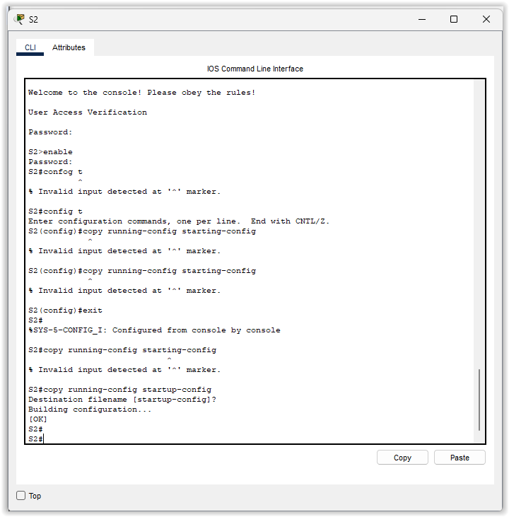

**Part 2: Configure the PCs**

**Configure both PCs with IP addresses**

**Test connectivity to switches.**

**Were you successful? Explain.**

The ping was unsuccessful as we have not set an IP address for the switch.

**Part 3: Configure the Switch Management Interface**

**Configure S1 with an IP address.**

**Why do you enter the no shutdown command?**

The no shutdown command turns on the interface.

**Configure S2 with an IP address.**

**Verify the IP address configuration on S1 and S2.**

**Save configurations for S1 and S2 to NVRAM.**

**Verify network connectivity.**

**Ping the IP address for S1 from PC1.**

**Ping the IP address for S2 from PC1.**

**Ping the IP address for PC2 from PC1.**

**Ping the IP address for S1 from PC2.**

**Ping the IP address for S2 from PC2.**

**Ping the IP address for PC1 from PC2.**

**PART C: Packet Tracer - Basic Switch and End Device Configuration -Physical Mode**

**Part 1: Set Up the Network Topology**

**Part 2: Configure PC Hosts**

**Part 3: Configure and Verify Basic Switch Settings**

**Why are some FastEthernet ports on the switches up while others are down?**

Because we have not set a dedicated IP address for the ports and switch on the interface.

**What could prevent a ping from being sent between the PCs?**

Theres probably something wrong with the cable wire, or the firewall is turned on.